**Data Collection and Preprocessing Phase**

|  |  |
| --- | --- |
| Date | 28 June 2024 |
| Team ID | 739860 |
| Project Title | A Comprehensive Measure Of Well-Being:A  Human Development Using Machine Learning |
| Maximum Marks | 6 Marks |

**Data Exploration and Preprocessing Report**

Dataset variables will be statistically analyzed to identify patterns and outliers, with Python employed for preprocessing tasks like normalization and feature engineering. Data cleaning will address missing values and outliers, ensuring quality for subsequent analysis and modeling, and forming a strong foundation for insights and predictions.

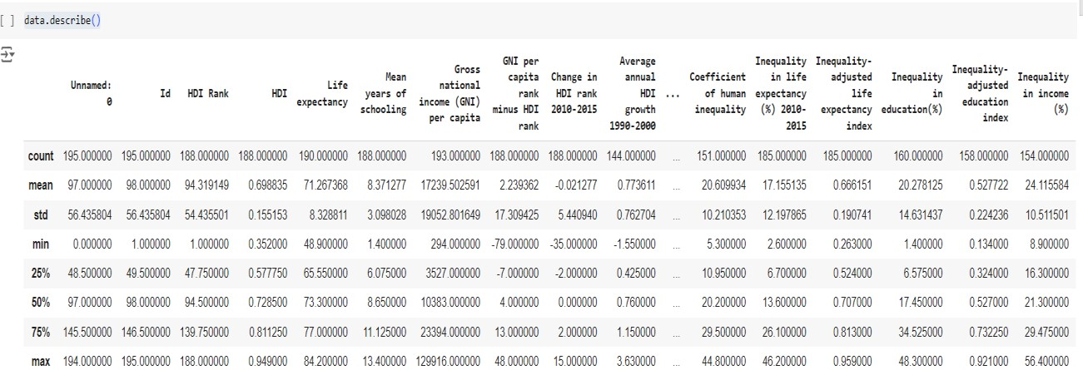

|  |  |
| --- | --- |
|  |  |

|  |  |
| --- | --- |
| Bivariate Analysis |  |

|  |  |
| --- | --- |
| Multivariate Analysis |  |

|  |  |
| --- | --- |
| Outliers and Anomalies | - |
| **Data Preprocessing Code Screenshots** | |

|  |  |
| --- | --- |
| Loading Data |  |
| Handling  Missing Data |  |
| Data  Transformation |  |

|  |  |
| --- | --- |
| Feature  Engineering | Attached the codes in final submission. |
| Save  Processed Data | - |